Ruthvik Udutha **Assignment 3** Date:

(UFID : 3311-9706) (COP-5725 DBMS) 22th Oct,2019

Exercise 1

1.

[4 points] What is the meaning of these keywords?

For a database, all the constraints will be immediately applied. A constraint’s deferrable characteristic can be used to change this nature. Deferrable constraints are validated at transaction level and not statement level. There are two types of deferrable constraints : INITIALLY IMMEDIATE, INITIALLY DEFERRED.

DIFERRABLE : Allows the database constraint to change its default constraint behaviour.

The deferrable behaviour can be specified by using the below key words following DIFFERABLE key word.

INITIALLY DEFERRED : Unless we commit the data into the database, it won’t check for constraints

INITIALLY IMMEDIATE : Constraint is checked when we update, delete or add rows from a table.

2.

[6 points] Why is the action indicated by the keyword INITIALLY DEFERRED DEFERRABLE needed in the scenario above? What is the problem? How is the problem solved?

The Foreign key of country (Code, Capital, Province) is referencing to the attributes (Country, Name, Province) of the City table. Similarly we observe that attributes (Country, Province) of City are referencing to attributes (Country, Name) of Province, attributes of Province (Country) is referencing to attributes (Code) of Country and attributes (Capital, Country, CapProv) of Province are referencing to attributes (Name, Country, Province) of City.

The problem here is at the beginning when no table and rows were created and while we try to create and insert, we will face error due to referential integrity constraint. For example at the time of inserting into country, the error is thrown because City table is not created (and Referential integrity constraint exists on Country since attributes in Country are referencing to a few attributes in City). Similar reasoning can be applied to the other tables as well.

This problem is solved by using the “INITIALLY DEFERRED DEFERRABLE” key words. This allows us to change the database constraint behaviour. Now unless we commit the data into the database, it won’t check for referential constraints. Hence we solve the problem by committing the data into the data base after we fill in the tables : Country, City, Province. And from now on the constraints (referential integrity constraint) will be checked (i.e. after committing and not before)

**SQL Queries:**

**1.**

SELECT

country.name

FROM

country

JOIN economy ON country.code = economy.country

WHERE

economy.agriculture > 50;

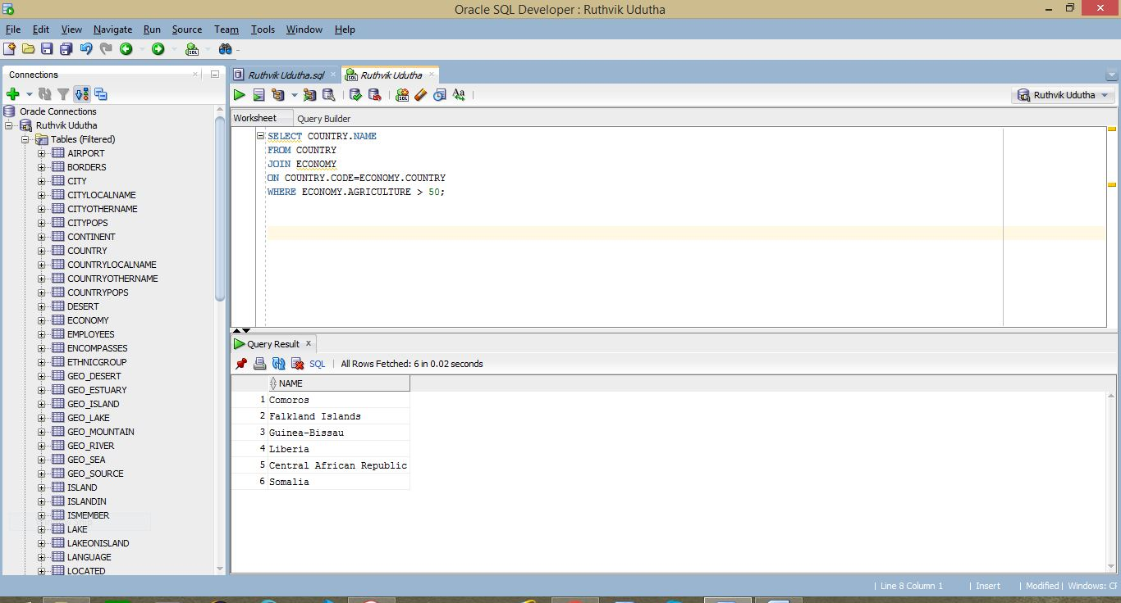

**2.**

SELECT

name

FROM

(

SELECT

name,

( population * power((1 + nvl(population_growth, 0)), 5) ) AS after_5

FROM

(

SELECT

country.population,

population.population_growth,

country.name

FROM

( country

JOIN population ON country.code = population.country )

)

ORDER BY

after_5 DESC

)

WHERE

ROWNUM <= 5;

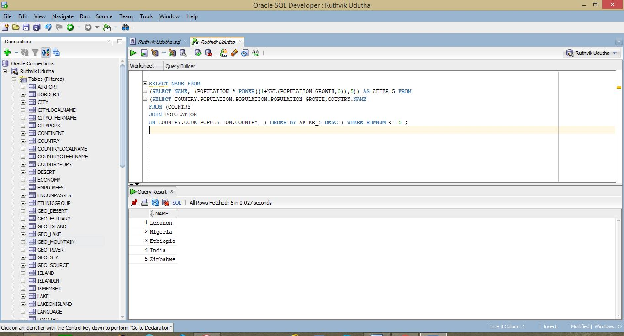

**3.**

SELECT

(

SELECT

name

FROM

country

WHERE

code IN (

SELECT

"country_used_to"

FROM

(

SELECT

nvl(wasdependent, 0) AS "country_used_to",

COUNT(country) AS prev_count

FROM

politics

GROUP BY

wasdependent

ORDER BY

prev_count DESC

)

WHERE

"country_used_to" != '0'

AND prev_count = (

SELECT

MAX(prev_count)

FROM

(

SELECT

nvl(wasdependent, 0) AS "country_used_to",

COUNT(country) AS prev_count

FROM

politics

GROUP BY

wasdependent

ORDER BY

prev_count DESC

)

WHERE

"country_used_to" != '0'

)

)

) "c1",

(

SELECT

prev_count

FROM

(

SELECT

nvl(wasdependent, 0) AS "country_used_to",

COUNT(country) AS prev_count

FROM

politics

GROUP BY

wasdependent

ORDER BY

prev_count DESC

)

WHERE

"country_used_to" != '0'

AND prev_count = (

SELECT

MAX(prev_count)

FROM

(

SELECT

nvl(wasdependent, 0) AS "country_used_to",

COUNT(country) AS prev_count

FROM

politics

GROUP BY

wasdependent

ORDER BY

prev_count DESC

)

WHERE

"country_used_to" != '0'

)

) "n1",

(

SELECT

name

FROM

country

WHERE

code IN (

SELECT

"country_now"

FROM

(

SELECT

nvl(dependent, 0) AS "country_now",

COUNT(country) AS now_count

FROM

politics

GROUP BY

dependent

ORDER BY

now_count DESC

)

WHERE

"country_now" != '0'

AND now_count = (

SELECT

MAX(now_count)

FROM

(

SELECT

nvl(dependent, 0) AS "country_now",

COUNT(country) AS now_count

FROM

politics

GROUP BY

dependent

ORDER BY

now_count DESC

)

WHERE

"country_now" != '0'

)

)

) "c2",

(

SELECT

now_count

FROM

(

SELECT

nvl(dependent, 0) AS "country_now",

COUNT(country) AS now_count

FROM

politics

GROUP BY

dependent

ORDER BY

now_count DESC

)

WHERE

"country_now" != '0'

AND now_count = (

SELECT

MAX(now_count)

FROM

(

SELECT

nvl(dependent, 0) AS "country_now",

COUNT(country) AS now_count

FROM

politics

GROUP BY

dependent

ORDER BY

now_count DESC

)

WHERE

"country_now" != '0'

)

) "n2",

( (

SELECT

prev_count

FROM

(

SELECT

nvl(wasdependent, 0) AS "country_used_to",

COUNT(country) AS prev_count

FROM

politics

GROUP BY

wasdependent

ORDER BY

prev_count DESC

)

WHERE

"country_used_to" != '0'

AND prev_count = (

SELECT

MAX(prev_count)

FROM

(

SELECT

nvl(wasdependent, 0) AS "country_used_to",

COUNT(country) AS prev_count

FROM

politics

GROUP BY

wasdependent

ORDER BY

prev_count DESC

)

WHERE

"country_used_to" != '0'

)

) - (

SELECT

now_count

FROM

(

SELECT

nvl(dependent, 0) AS "country_now",

COUNT(country) AS now_count

FROM

politics

GROUP BY

dependent

ORDER BY

now_count DESC

)

WHERE

"country_now" != '0'

AND now_count = (

SELECT

MAX(now_count)

FROM

(

SELECT

nvl(dependent, 0) AS "country_now",

COUNT(country) AS now_count

FROM

politics

GROUP BY

dependent

ORDER BY

now_count DESC

)

WHERE

"country_now" != '0'

)

) ) "difference"

FROM

dual

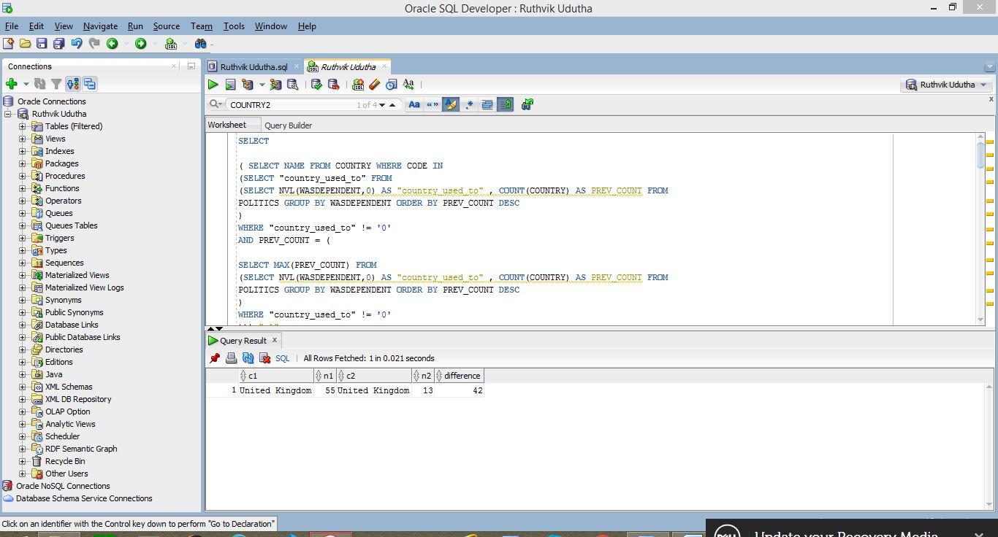

**4.**

SELECT

c.name

FROM

( country c

JOIN religion r ON c.code = r.country )

WHERE

percentage > 80

AND c.name IN (

SELECT

cname

FROM

(

SELECT

name AS cname,

COUNT(DISTINCT relname) AS relnum

FROM

(

SELECT

country.name,

religion.name AS relname,

religion.percentage

FROM

( country

JOIN religion ON country.code = religion.country )

)

GROUP BY

name

)

WHERE

relnum > 4

)

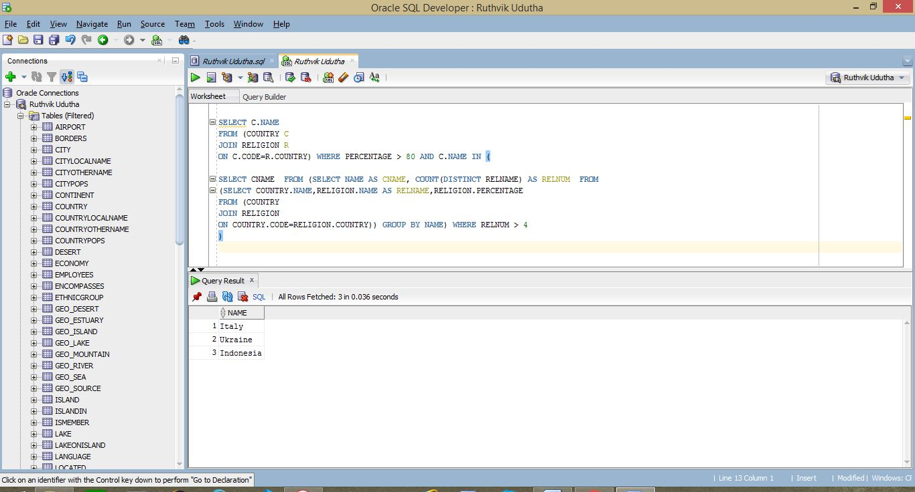

**5.**

SELECT

SUM(length)

FROM

(

SELECT

*

FROM

borders

WHERE

country1 IN (

SELECT

code

FROM

country

WHERE

name = 'China'

)

OR country2 IN (

SELECT

code

FROM

country

WHERE

name = 'China'

)

);

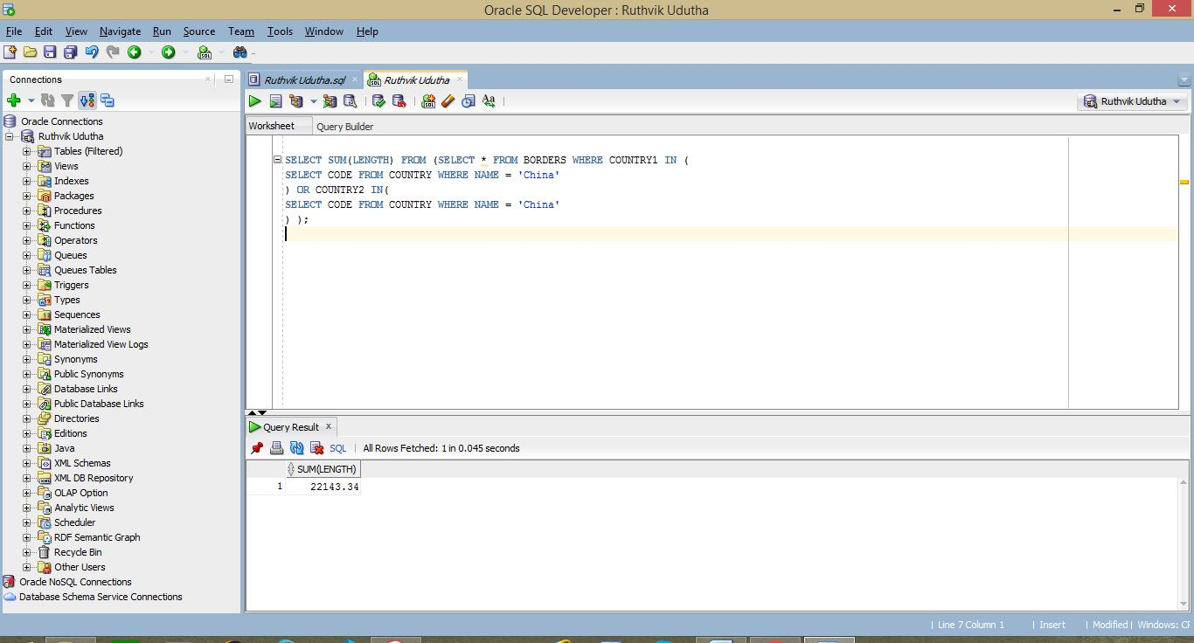

**6.**

SELECT

*

FROM

(

SELECT

name,

SUM(pop_per_rel) AS num_followers

FROM

(

SELECT

r.country,

r.name,

r.percentage,

c.population,

( ( percentage / 100 ) * population ) AS pop_per_rel

FROM

(

SELECT

*

FROM

religion

) r

JOIN (

SELECT

code,

population

FROM

country

) c ON r.country = c.code

)

GROUP BY

name

ORDER BY

num_followers DESC

)

WHERE

ROWNUM <= 5

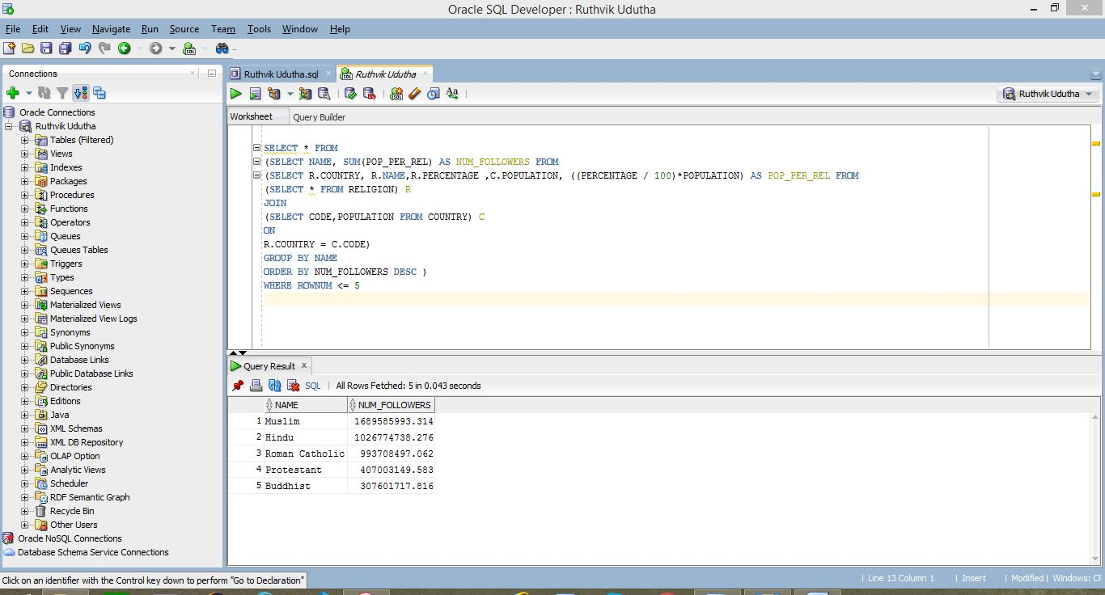

**7.**

SELECT DISTINCT

name

FROM

(

SELECT

l.name,

l.elevation,

g.country

FROM

geo_lake g

JOIN lake l ON g.lake = l.name

WHERE

g.country IN (

SELECT

code

FROM

country

WHERE

name = 'United States'

)

)

WHERE

elevation > (

SELECT

AVG(elevation)

FROM

lake

);

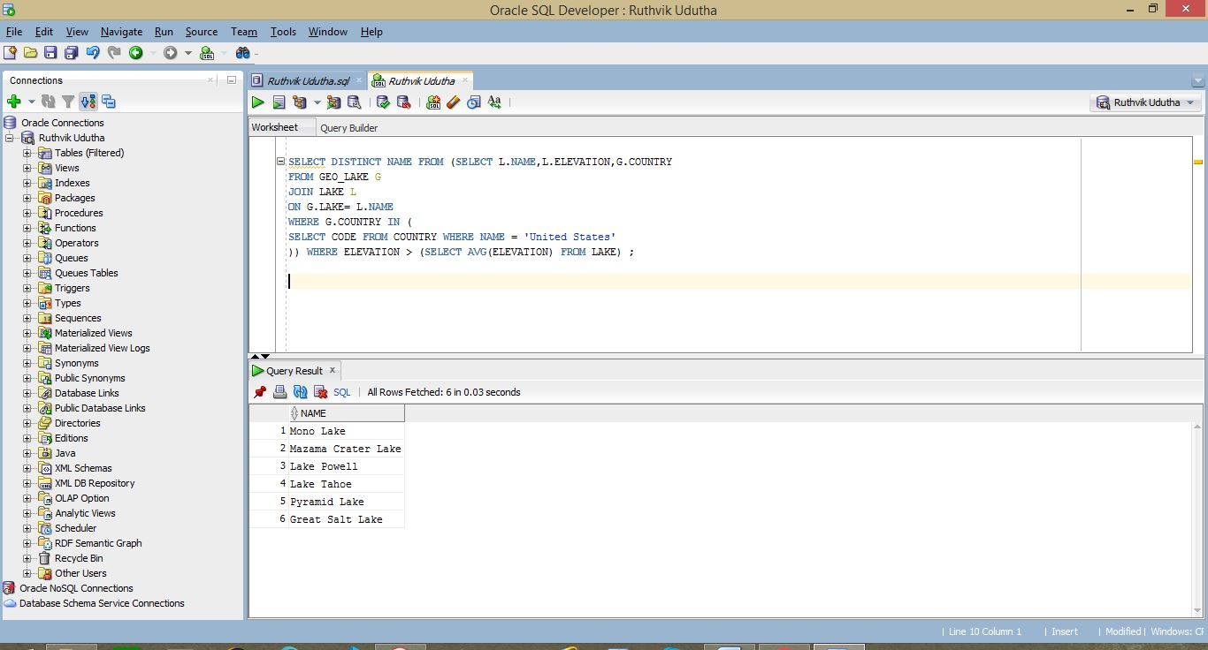

**8.**

SELECT

*

FROM

(

SELECT

t.name AS mountain_name,

t.province,

j.population_density

FROM

(

SELECT

m.name,

m.type,

g.province,

g.country

FROM

mountain m

JOIN geo_mountain g ON m.name = g.mountain

WHERE

type = 'volcano'

) t

JOIN (

SELECT

name,

( population / area ) AS population_density

FROM

province

) j ON t.province = j.name

ORDER BY

population_density DESC

)

WHERE

population_density IN (

(

SELECT

MAX(population_density)

FROM

(

SELECT

t.name AS mountain_name,

t.province,

j.population_density

FROM

(

SELECT

m.name,

m.type,

g.province,

g.country

FROM

mountain m

JOIN geo_mountain g ON m.name = g.mountain

WHERE

type = 'volcano'

) t

JOIN (

SELECT

name,

( population / area ) AS population_density

FROM

province

) j ON t.province = j.name

ORDER BY

population_density DESC

)

)

)

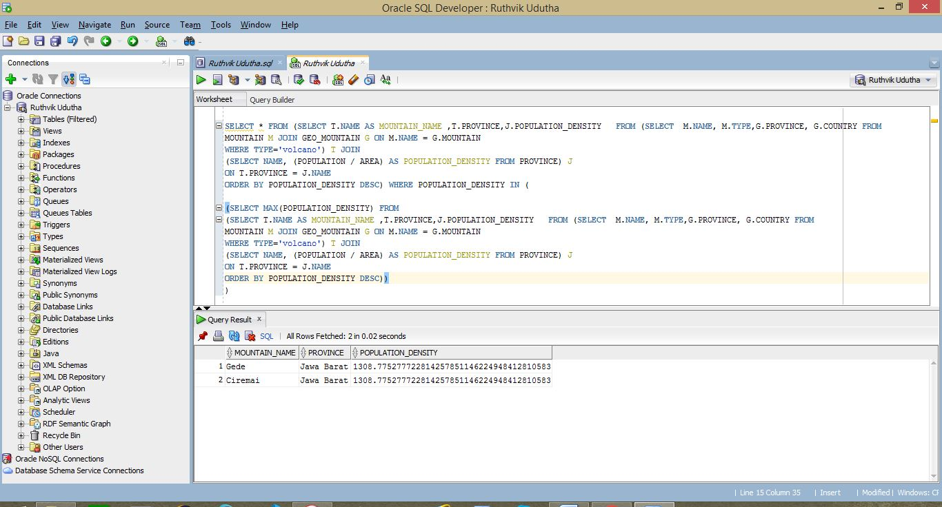

**9.**

SELECT

*

FROM

(

SELECT

t2.province,

t2.island_count,

t2.country,

e.gdp

FROM

(

SELECT

t.province,

t.island_count,

p.country

FROM

(

SELECT

*

FROM

(

SELECT

province,

COUNT(island) AS island_count

FROM

geo_island

GROUP BY

province

)

WHERE

island_count > 2

) t

JOIN province p ON t.province = p.name

) t2

JOIN economy e ON t2.country = e.country

)

WHERE

gdp > 1000000

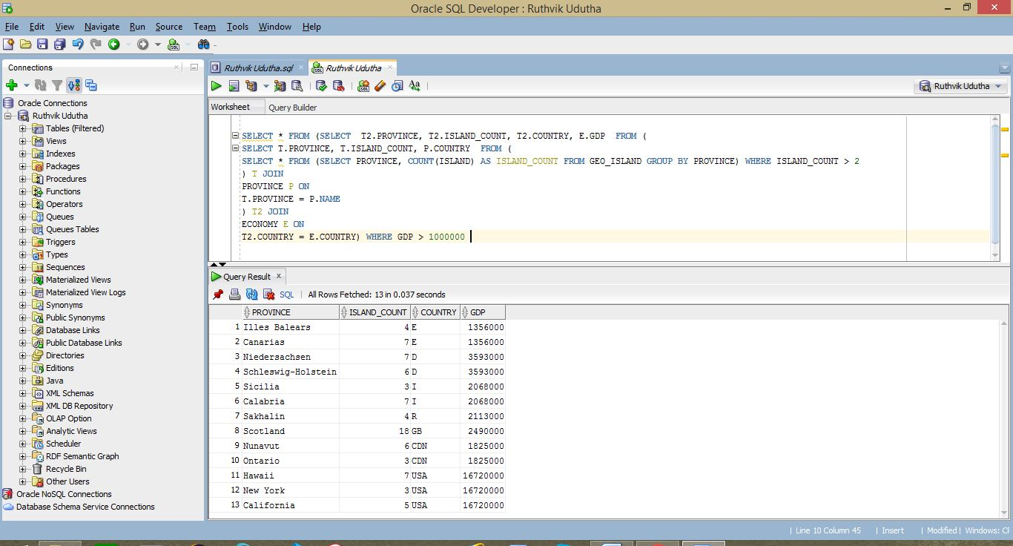

**10.**

SELECT

name,

length

FROM

(

SELECT

*

FROM

(

SELECT

*

FROM

river

WHERE

sea = 'Atlantic Ocean'

) r

JOIN (

SELECT

river,

COUNT(name) AS lake_count

FROM

lake

GROUP BY

river

) l ON r.name = l.river

ORDER BY

r.length DESC

)

WHERE

ROWNUM <= 2

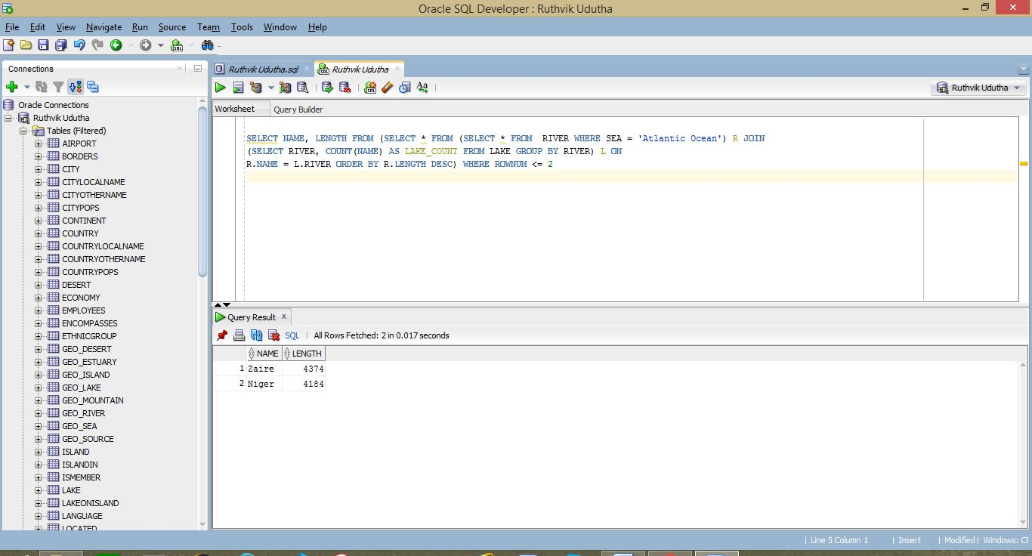

**11.**

SELECT

name

FROM

country

WHERE

code IN (

SELECT DISTINCT

r_country

FROM

(

SELECT

lake,

country AS l_country

FROM

geo_lake

WHERE

lake IN (

SELECT

lake

FROM

(

SELECT

lake,

COUNT(province) AS province_count

FROM

geo_lake

GROUP BY

lake

)

WHERE

province_count > 3

)

) l

JOIN (

SELECT

*

FROM

(

SELECT

country AS r_country,

COUNT(river) AS river_count

FROM

geo_river

GROUP BY

country

)

WHERE

river_count > 3

) r ON l.l_country = r.r_country

)

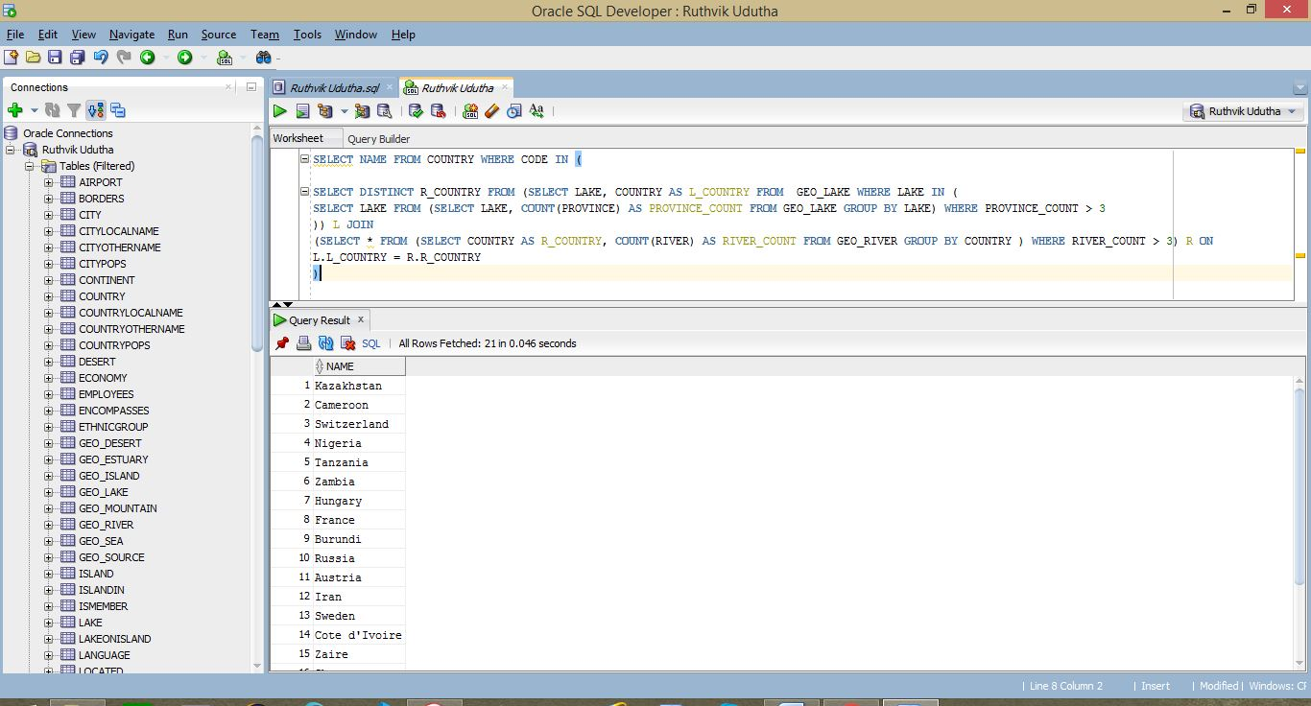

**13.**

SELECT

continent,

MAX(highest_peak) AS highest_elevation

FROM

(

SELECT

*

FROM

(

SELECT

country,

MAX(elevation) AS highest_peak

FROM

(

SELECT

name,

elevation,

country

FROM

mountain m

JOIN geo_mountain gm ON m.name = gm.mountain

)

GROUP BY

country

) p

JOIN (

SELECT

country,

continent

FROM

encompasses

) c ON p.country = c.country

)

GROUP BY

continent

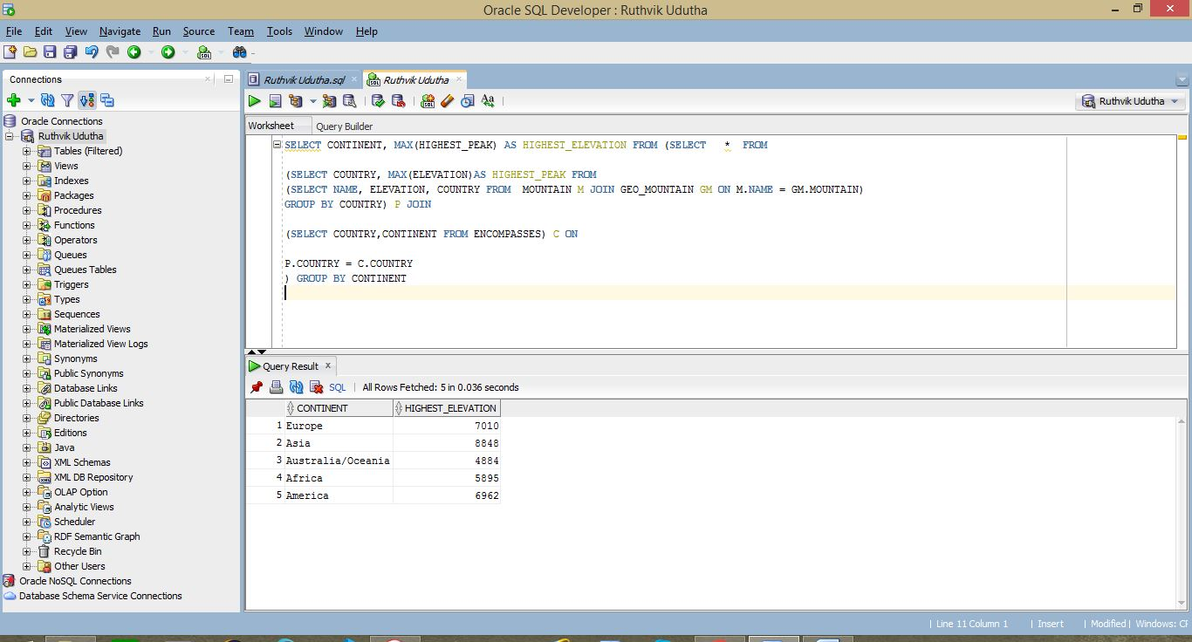

**14.**

SELECT

c.name,

temp.max_elevation,

temp.max_depth

FROM

country c

JOIN (

SELECT

mountain.country,

mountain.max_elevation,

sea.max_depth

FROM

( (

SELECT

country,

MAX(elevation) AS max_elevation

FROM

(

SELECT

*

FROM

mountain m

JOIN geo_mountain g ON m.name = g.mountain

)

GROUP BY

country

) mountain

JOIN (

SELECT

country,

MAX(depth) AS max_depth

FROM

(

SELECT

*

FROM

sea s

JOIN geo_sea gs ON s.name = gs.sea

)

GROUP BY

country

) sea ON mountain.country = sea.country )

WHERE

mountain.max_elevation > sea.max_depth

) temp ON c.code = temp.country

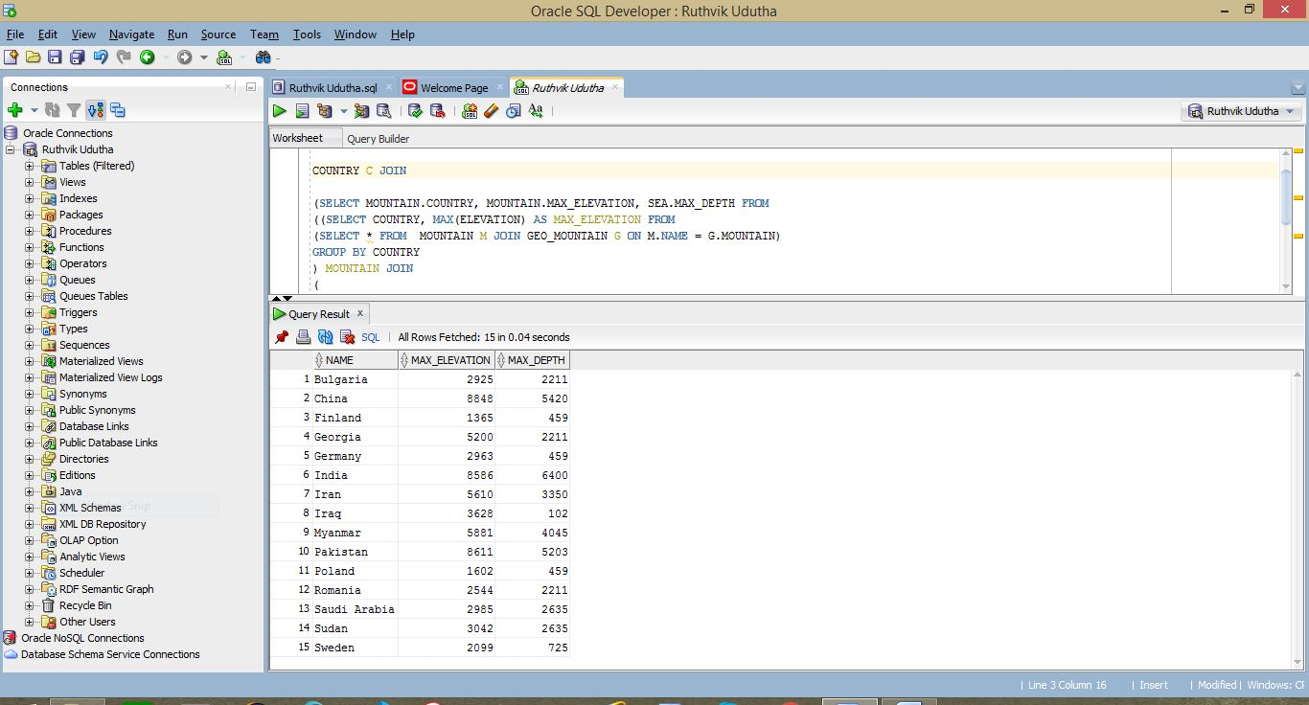

**15.**

SELECT

name,

continent

FROM

(

SELECT

cl1.name,

cl1.latitude,

co1.continent

FROM

(

SELECT

name,

latitude

FROM

city

WHERE

country NOT IN (

SELECT

country AS country_encp

FROM

encompasses

WHERE

continent = 'Asia'

)

) cl1

JOIN (

SELECT

continent,

MAX(latitude) AS max_latitude

FROM

(

SELECT

ci.country,

ci.name AS city_name,

c.continent,

ci.latitude

FROM

(

SELECT

country AS country_encp,

continent

FROM

encompasses

WHERE

continent != 'Asia'

AND country NOT IN (

SELECT

country AS country_encp

FROM

encompasses

WHERE

continent = 'Asia'

)

) c

JOIN (

SELECT

*

FROM

city

WHERE

country IN (

SELECT

country

FROM

encompasses

WHERE

continent != 'Asia'

AND country NOT IN (

SELECT

country AS country_encp

FROM

encompasses

WHERE

continent = 'Asia'

)

)

) ci ON c.country_encp = ci.country

)

GROUP BY

continent

) co1 ON cl1.latitude = co1.max_latitude

)

ORDER BY

latitude DESC

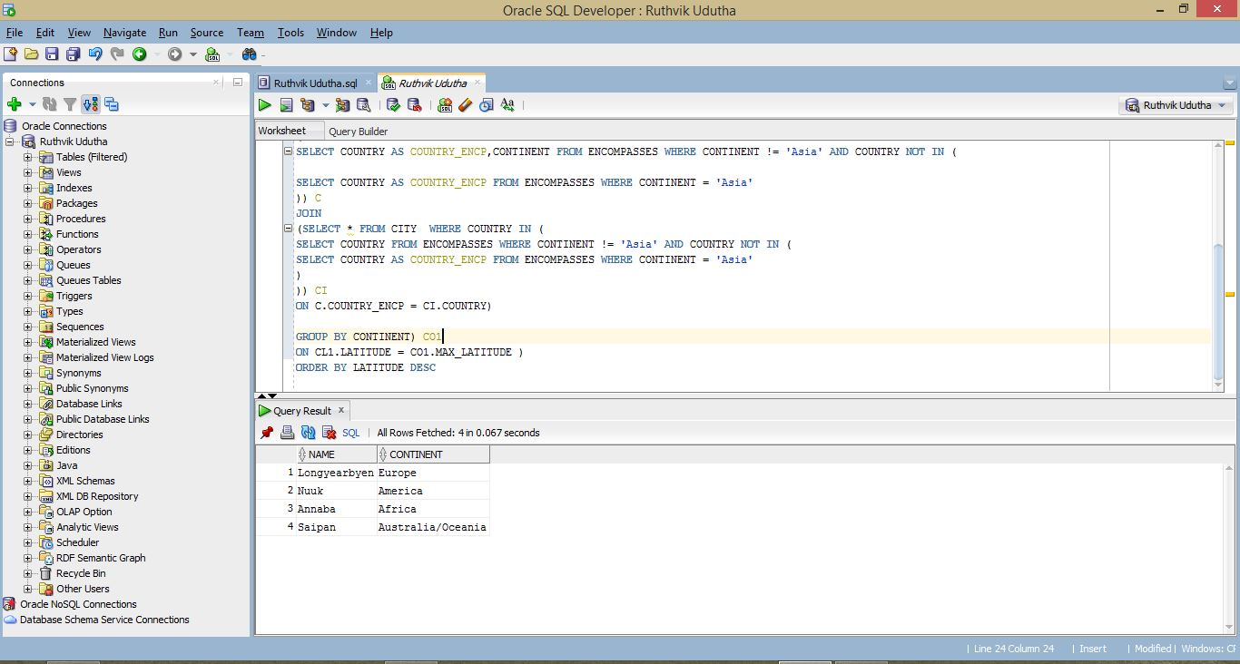

**16.**

SELECT

name

FROM

country

WHERE

code IN (

SELECT

country

FROM

city

WHERE

name IN (

SELECT

capital

FROM

country

)

AND latitude > 0

AND population < 10000

)

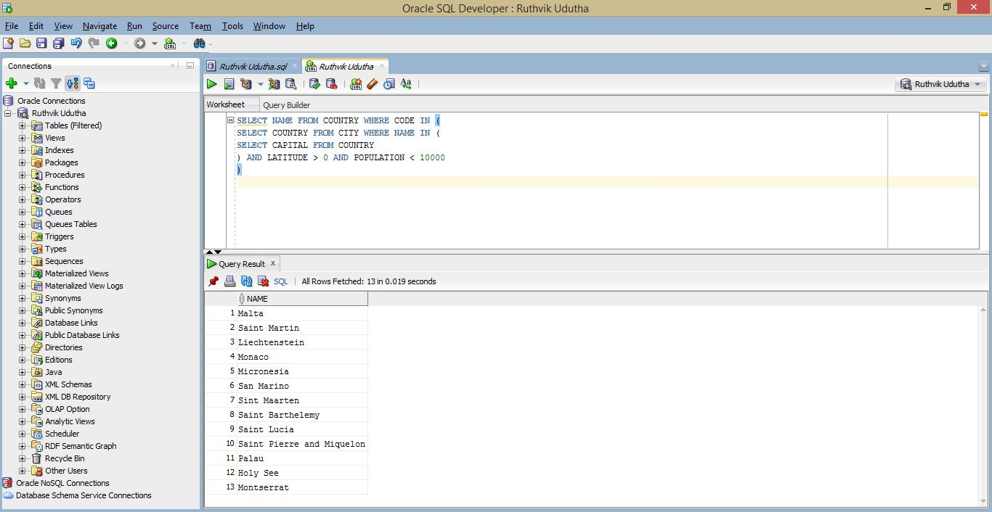

**17.**

SELECT

(

SELECT

SUM(area) AS "top10"

FROM

(

SELECT

name,

area

FROM

country

ORDER BY

area DESC

)

WHERE

ROWNUM <= 10

) "top10",

(

SELECT

SUM(area) AS "rest_world"

FROM

(

SELECT

name,

area

FROM

country

ORDER BY

area ASC

)

WHERE

ROWNUM < (

SELECT

COUNT(*)

FROM

(

SELECT

name,

area

FROM

country

ORDER BY

area DESC

)

) - 9

) "rest_world",

( (

SELECT

SUM(area) AS "top10"

FROM

(

SELECT

name,

area

FROM

country

ORDER BY

area DESC

)

WHERE

ROWNUM <= 10

) - ( (

SELECT

SUM(area) AS "rest_world"

FROM

(

SELECT

name,

area

FROM

country

ORDER BY

area ASC

)

WHERE

ROWNUM < (

SELECT

COUNT(*)

FROM

(

SELECT

name,

area

FROM

country

ORDER BY

area DESC

)

) - 9

) ) ) "difference"

FROM

dual

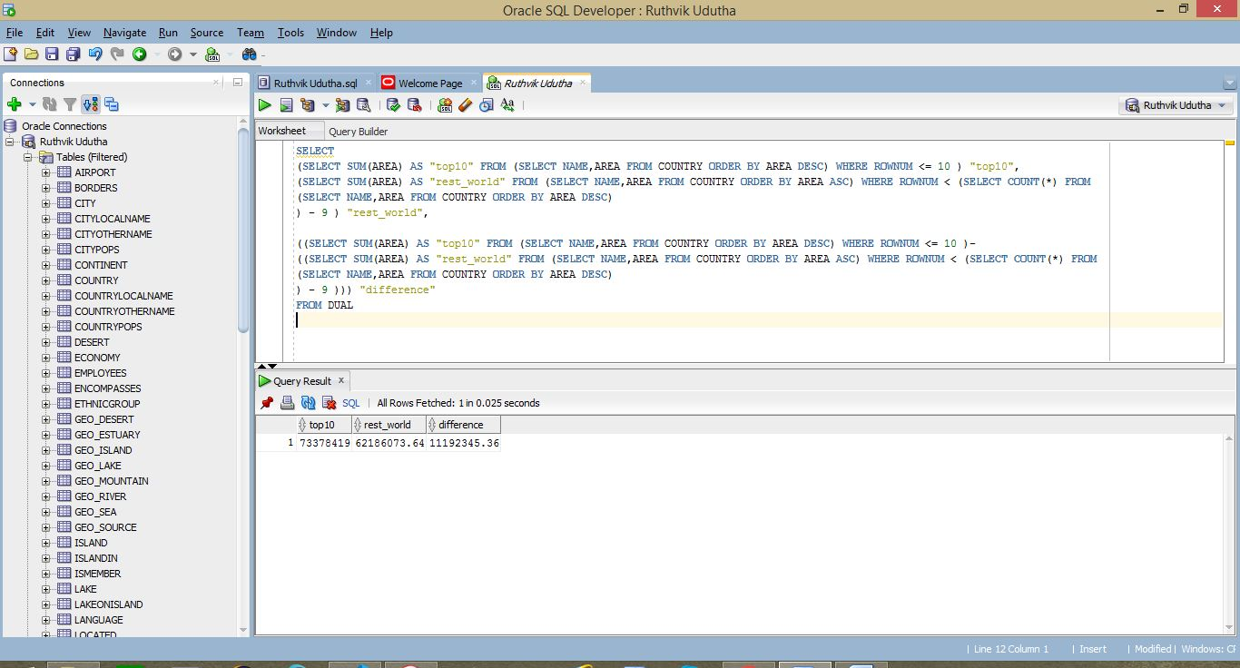

**18.**

SELECT

name

FROM

country

WHERE

code IN (

SELECT

country

FROM

(

SELECT

country,

COUNT(continent) AS cont_count

FROM

encompasses

GROUP BY

country

)

WHERE

cont_count > 1

)

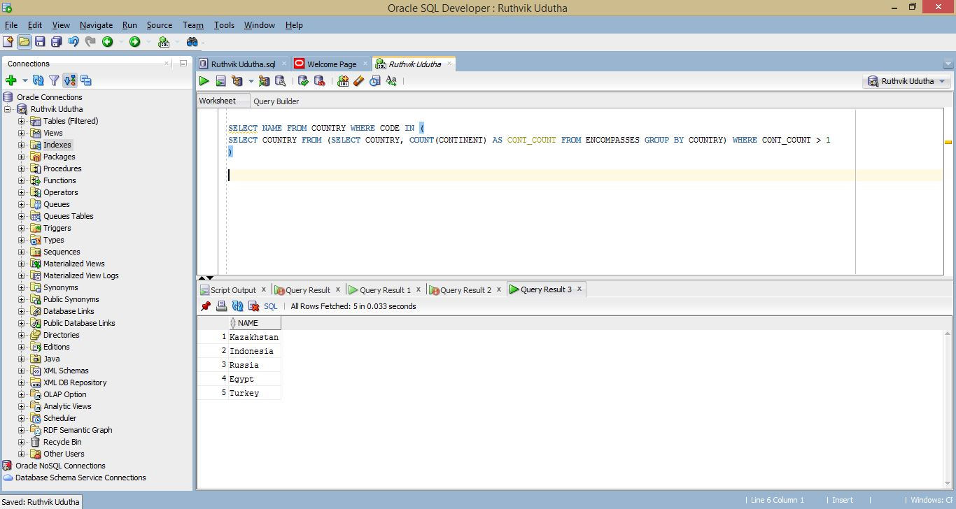

**19.**

SELECT

i.name,

i.area

FROM

(

SELECT

name,

area

FROM

island

WHERE

area > 1000

) i

JOIN (

SELECT

*

FROM

geo_island

WHERE

country IN (

SELECT

country

FROM

encompasses

WHERE

continent = 'Africa'

)

) g ON i.name = g.island

ORDER BY

i.area DESC

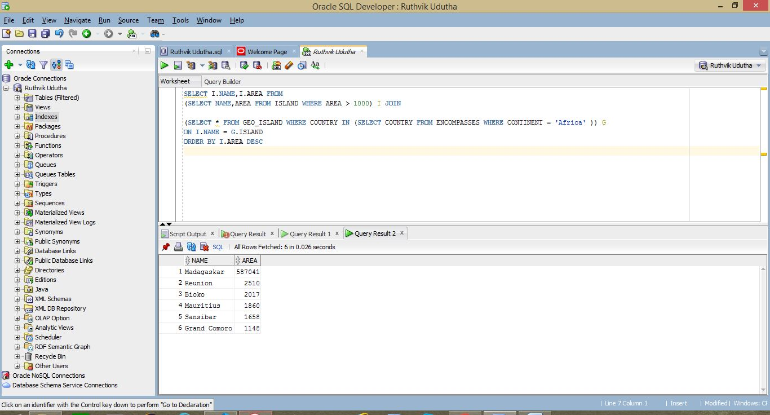

**20.**

SELECT

t.name,

g.gdp

FROM

(

SELECT

country,

gdp

FROM

economy

WHERE

country IN (

SELECT

country

FROM

religion

WHERE

country IN (

SELECT

country

FROM

ismember

WHERE

organization = 'NATO'

)

AND name = 'Muslim'

AND percentage > 5

)

) g

JOIN (

SELECT

name,

code

FROM

country

) t ON g.country = t.code

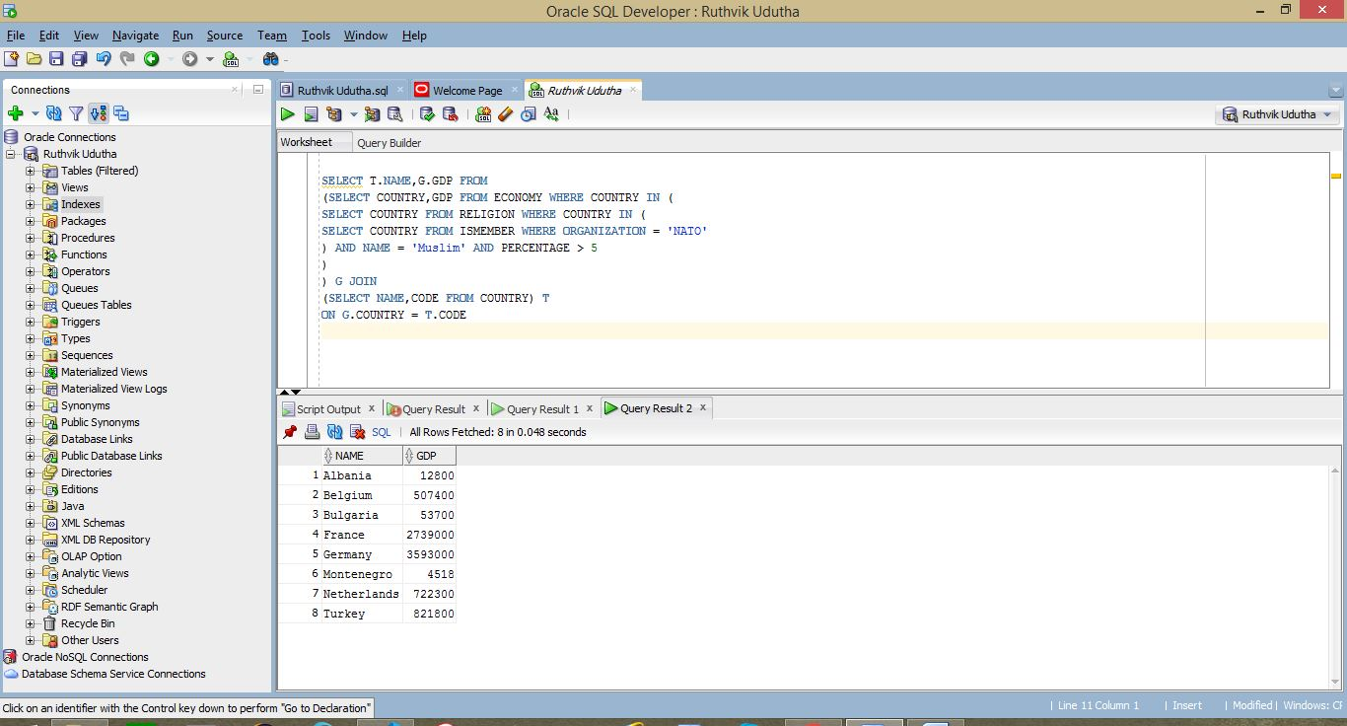

**21.**

SELECT

river

FROM

(

SELECT

river,

COUNT(*) AS prov_count

FROM

geo_river

GROUP BY

river,

country

)

WHERE

prov_count >= 12

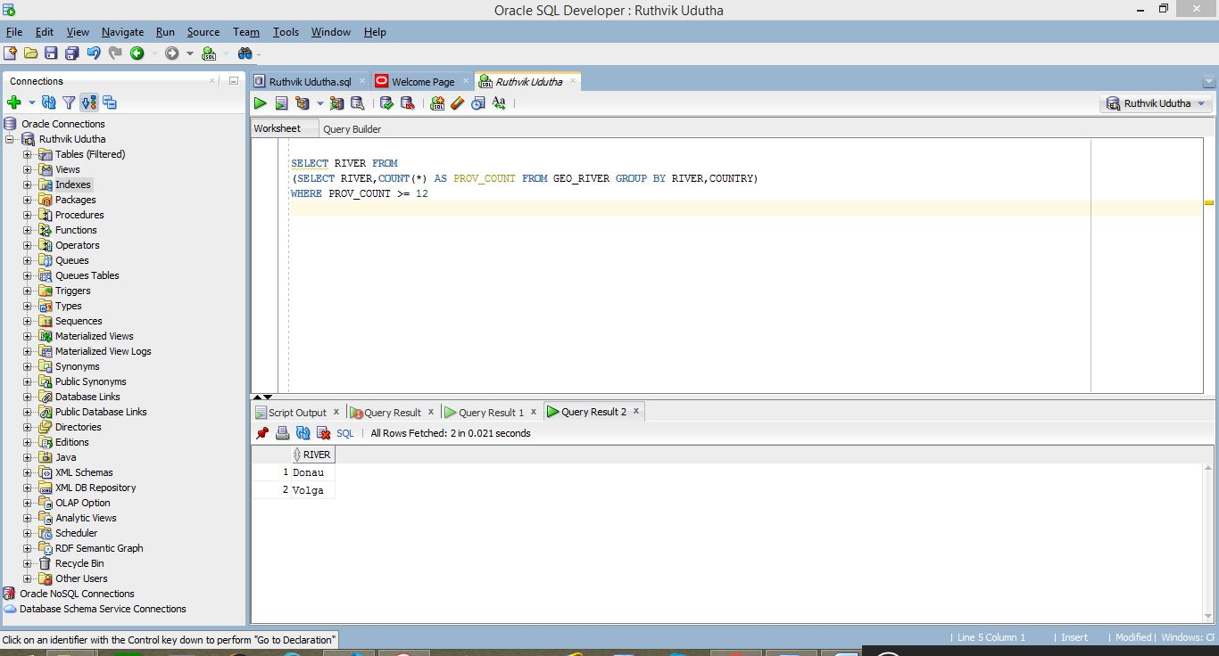

**22.**

SELECT

river_name,

length

FROM

(

SELECT DISTINCT

g.river AS river_name,

g.country,

r.length

FROM

( (

SELECT

river,

country

FROM

geo_river

) g

JOIN (

SELECT

name,

length

FROM

river

) r ON g.river = r.name )

WHERE

country IN (

SELECT

country

FROM

encompasses

WHERE

continent = 'America'

)

ORDER BY

r.length DESC

)

WHERE

length = (

SELECT

MAX(r.length)

FROM

( (

SELECT

river,

country

FROM

geo_river

) g

JOIN (

SELECT

name,

length

FROM

river

) r ON g.river = r.name )

WHERE

country IN (

SELECT

country

FROM

encompasses

WHERE

continent = 'America'

)

)

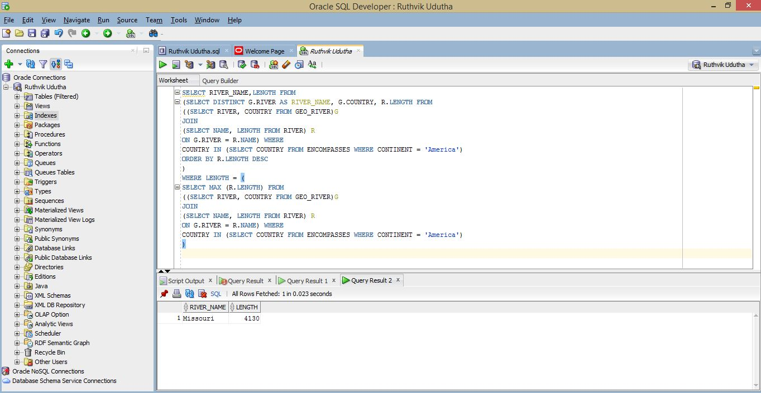

**23.**

SELECT

*

FROM

(

SELECT DISTINCT

i.province,

i.count_islands,

g.country AS country_code

FROM

(

SELECT

COUNT(island) AS count_islands,

province

FROM

geo_island

GROUP BY

province

ORDER BY

count_islands DESC

) i

JOIN geo_island g

ON i.province = g.province

ORDER BY

count_islands DESC

)

WHERE

count_islands = (

SELECT

MAX(count_islands)

FROM

(

SELECT

COUNT(island) AS count_islands,

province

FROM

geo_island

GROUP BY

province

ORDER BY

count_islands DESC

)

)

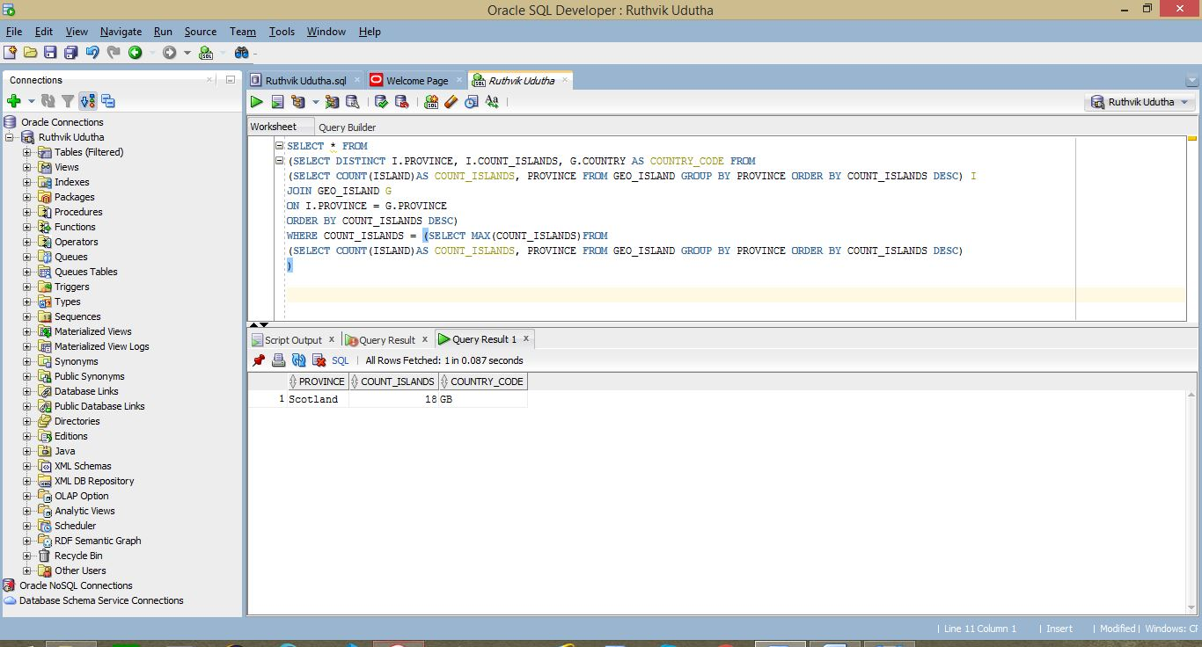

**24.**

SELECT

name AS "Country Name",

population_density AS "Population Density",

( ( population / wp ) * 100 ) AS "Percentage"

FROM

(

SELECT

name,

population,

( population / area ) AS population_density,

(

SELECT

SUM(population) AS world_pop

FROM

country

) AS wp

FROM

country

ORDER BY

( population_density ) DESC

)

WHERE

ROWNUM <= 10

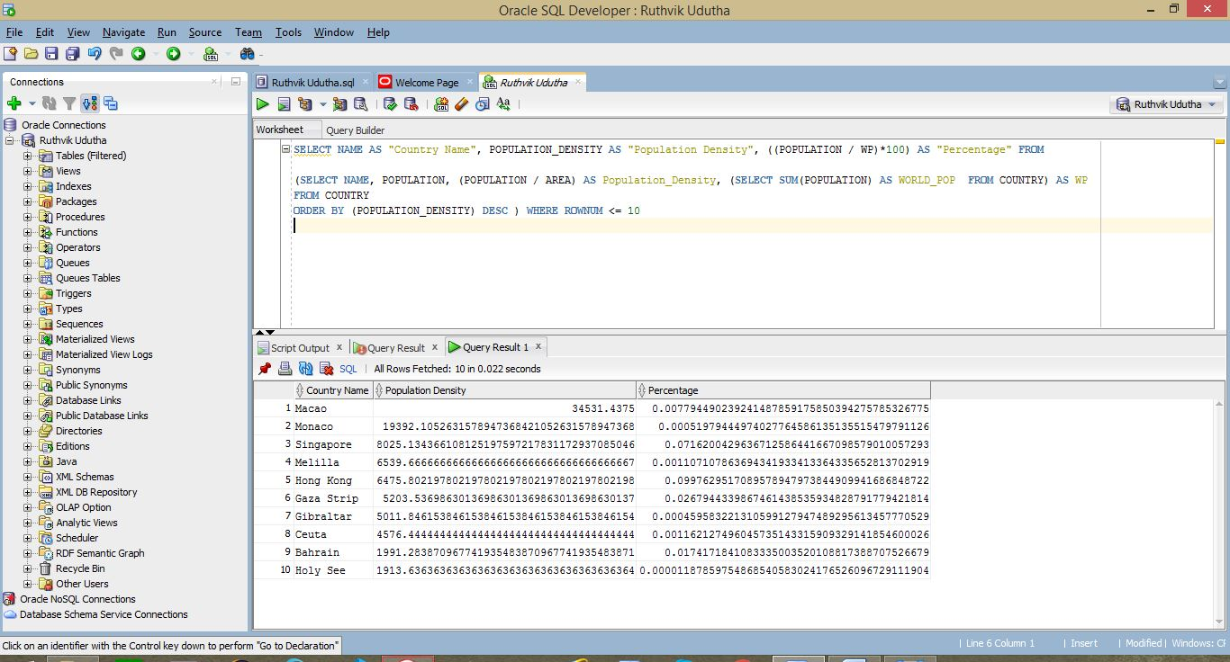

**25.**

SELECT

name

FROM

organization

WHERE

abbreviation IN (

SELECT

abbreviation

FROM

(

SELECT DISTINCT

abbreviation

FROM

(

SELECT

abbreviation,

name

FROM

organization

) o

JOIN (

SELECT

*

FROM

ismember

WHERE

country IN (

SELECT

country

FROM

encompasses

WHERE

continent = 'Asia'

)

) n ON o.abbreviation = n.organization

)

WHERE

abbreviation NOT IN (

SELECT

non_asia.abbreviation

FROM

(

SELECT DISTINCT

abbreviation

FROM

(

SELECT

abbreviation,

name

FROM

organization

) o

JOIN (

SELECT

*

FROM

ismember

WHERE

country IN (

SELECT

country

FROM

encompasses

WHERE

continent = 'Asia'

)

) n ON o.abbreviation = n.organization

) asia

JOIN (

SELECT DISTINCT

abbreviation

FROM

(

SELECT

abbreviation,

name

FROM

organization

) o

JOIN (

SELECT

*

FROM

ismember

WHERE

country IN (

SELECT

country

FROM

encompasses

WHERE

continent != 'Asia'

)

) n ON o.abbreviation = n.organization

) non_asia ON asia.abbreviation = non_asia.abbreviation

)

)

--NAME OF ORGANIZATONS HAVING ASIAN MEMBER COUNTRIES

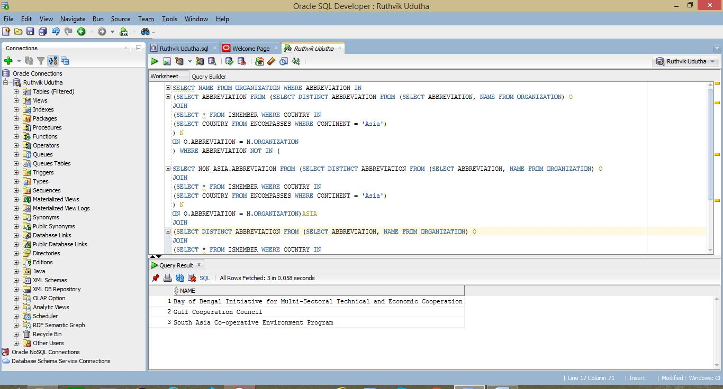

**12.**

SELECT

name

FROM

country

WHERE

code IN (

SELECT

country

FROM

geo_lake

WHERE

lake IN (

SELECT

name

FROM

lake

WHERE

area = (

SELECT

MAX(area)

FROM

lake

)

)

)

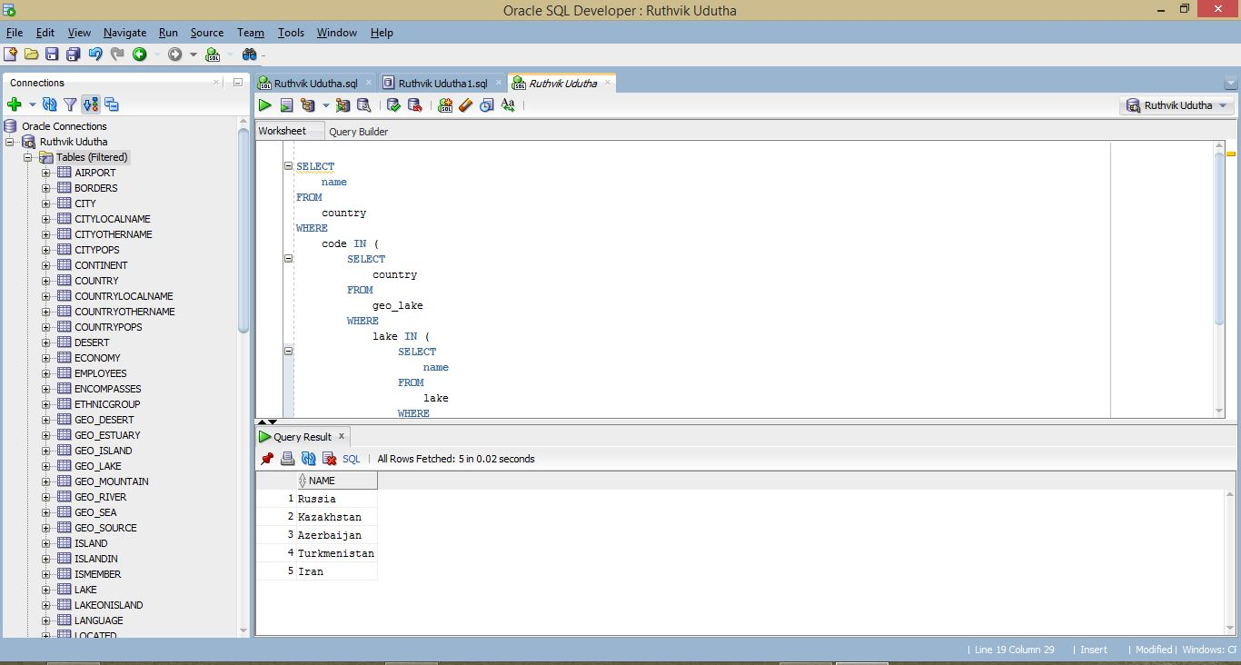

**Exercise 2 (QBE)**

1.

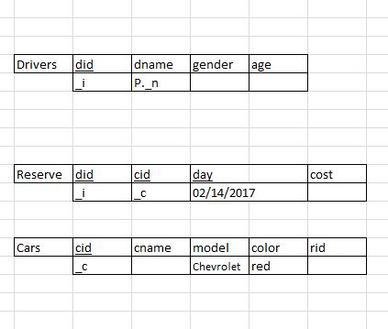

2.

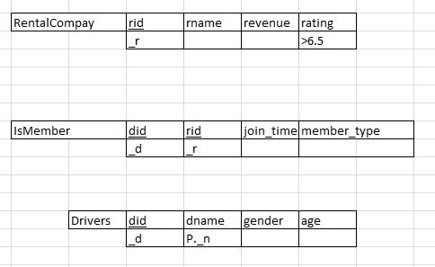

3.

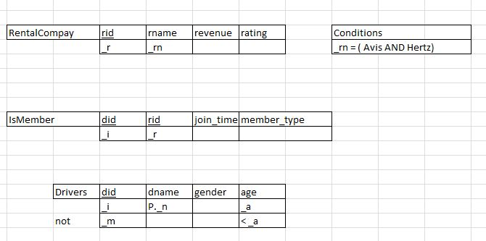

4.

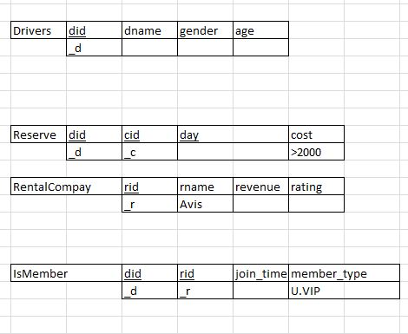

5.

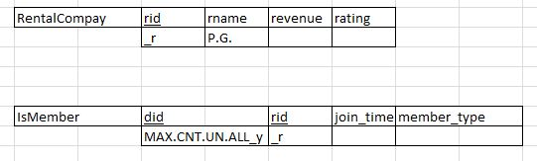

6.

